**Web Design and Development Foundations with HTML5**

**Hands-On Practice (HOP)**

HOP 11.1

When you run the code in the browser:

After you click "Podcast Episode 1":

After you click "Podcast Transcript":

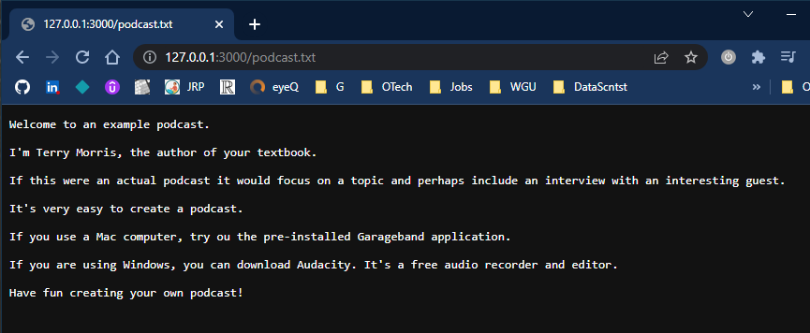

HOP 11.3

When you run the code in the browser:

After you click "Podcast Transcript":

HOP 11.4

HOP 11.5

HOP 11.6

HOP 11.7

HOP 11.8

HOP 11.9